**Why LPG Boilers Are More Efficient**

We spend more than 55% for energy bills payments per year, so it is really very important to have an efficient boiler which could not only heat our home properly but also save our money. The solution of this problem already exists and more and more people through the world use it.

What Is LPG?

LPG (also called LPG, GPL, LP Gas) is decrypted as liquid petroleum gas and from the point of view of CO2 emissions now is considered to be one of the most wholesome fuels used for warming vehicles and appliances. In fact, it is a flammable combination of hydrocarbon gases. LPG is very popular in aerosol propellants and refrigerants to replace chlorofluorocarbons trying to reduce damage of the ozone layer. Usually varieties of LPG can consist of both propane and butane. Depending on the season there is more propane in winter and more butane in summer.

Advantages of LPG Boilers

Comparing LPG with other heating methods it should be admitted that this gas has one of the lowest levels of producing CO2 per kilowatt hour:

* Natural Gas produces  194 g/kWh
* LPG produces  248 g/kWh
* Oil produces  270 g/kWh
* Solid Fuel produces  317 g/kWh
* Electricity produces 511 g/kWh.

LPG may be delivered in the cheapest way, directly into a permanent storage tank, so its price starts diminishing.

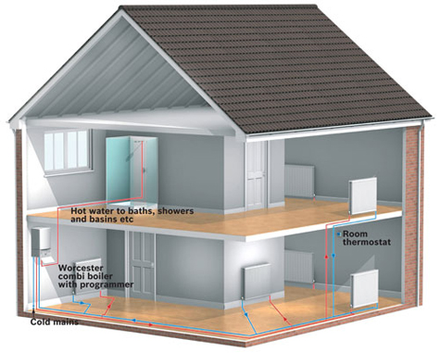

Though only 3% of the heating systems use liquid petroleum gas to fuel their boilers. Exactly this gas is recommended because of:

* They meet all the latest European requirements of safety, comfort and energy efficiency of modern heating systems
* They are very simple in its control and maintenance
* Nowadays there is a wide choice of LPG models that will satisfy every client
* You will be impressed with a high level of LPG boilers aftersales support
* LPG boilers can be bought ready to use or can be rebuilt from standard natural gas boilers
* LPG boilers need small main burner kits
* Though a starting price of LPG boiler is rather high, its annual energy efficiency can amount to 90%
* LPG boilers are provided with a central or individual storage tank with 1,000 and 2,000 litres capacity which can be easily refilled when the present is empty.

Due to all these advantages in some parts of Great Britain it is already very popular to use LPG instead of other types of fuels. The capacity of its tank allows warming a normal three-bedroomed well-insulated house and heating all the necessary volume of water without any problems.

We hope that you will estimate LPG boilers efficiency and facts that installation of these boilers will be quite cheap and maintenance will be absolutely easy and comfortable. Don’t forget that it is very significant to choose your future boiler correctly because your energy accounts depend on it.

from：<https://gasboilerguide.com/lpg-boiler-efficiency/>